POLITICAL DIRECTORY

State Legislators
Jo Comerford, MA State Senator  (Hampshire, Franklin & Worcester District) | Mindy Domb, MA State Representative  (3rd Hampshire District)
Jo.Comerford@masenate.gov | Mindy.Domb@mahouse.gov
(413) 367-4656 | (413) 335-1362
Massachusetts State House OR UMass Amherst  24 Beacon Street (shared with Rep. Domb)  Room 410  Boston, MA 02133 | Old Newman Center, UMass Amherst campus  472 N. Pleasant Street  Amherst, MA 01003-936

Amherst Town Council
https://www.amherstma.gov/3435/Town-Council (413) 259-3001 towncouncil@amherstma.gov

Amherst Town Council Members
Name | Title | Email | Term End
Hanneke, Mandi Jo | Councilor-at-Large | hannekem@amherstma.gov | Dec 31, 2025
Steinberg, Andrew J. | Councilor-at-Large | steinberga@amherstma.gov | Dec 31, 2025
Walker, Ellisha | Councilor-at-Large | walkere@amherstma.gov | Dec 31, 2025
Schoen, Cathy A. | District 1 Councilor | schoenc@amherstma.gov | Dec 31, 2025
Ette, Ndifreke | District 1 Councilor | ettef@amherstma.gov | Dec 31, 2025
De Angelis, Patricia C. | District 2 Councilor | deangelisp@amherstma.gov | Dec 31, 2025
Griesemer, Lynn  President | District 2 Councilor | griesemerl@amherstma.gov | Dec 31, 2025
Lord, Heather Hala | District 3 Councilor | lordh@amherstma.gov | Dec 31, 2025
Ryan, George  Vice President | District 3 Councilor | ryang@amherstma.gov | Dec 31, 2025
Rooney, Pamela | District 4 Councilor | rooneyp@amherstma.gov | Dec 31, 2025
Taub, Jennifer | District 4 Councilor | taubj@amherstma.gov | Dec 31, 2025
Devlin Gauthier, Ana | District 5 Councilor | devlingauthiera@amherstma.gov | Dec 31, 2025
Hegner, Robert (Bob) | District 5 Councilor | hegnerr@amherstma.gov | Dec 31, 2025

Town of Amherst, MA

Councilors-At-Large



Mandi Jo Hanneke Andrew J. Steinberg Ellisha Walker
District 1  Councilors | District 2 Councilors | District 3 Councilors | District 4 Councilors | District 5 Councilors
  Dr. Ndifreke (Freke) Ette  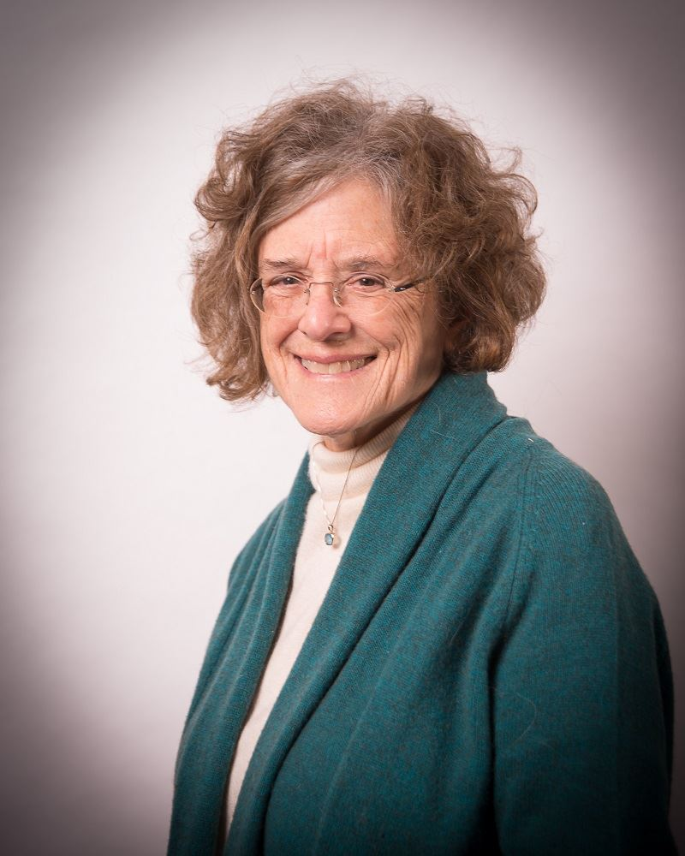  Cathy A. Schoen | 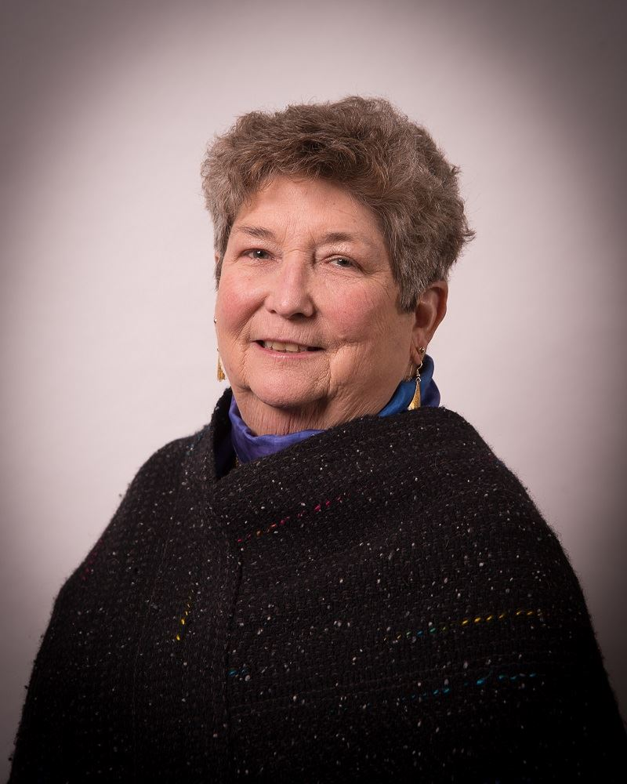  Lynn Griesemer Council President    Patricia C. De Angelis |   Heather Hala Lord    George E. Ryan  Council Vice President |   Pamela Rooney  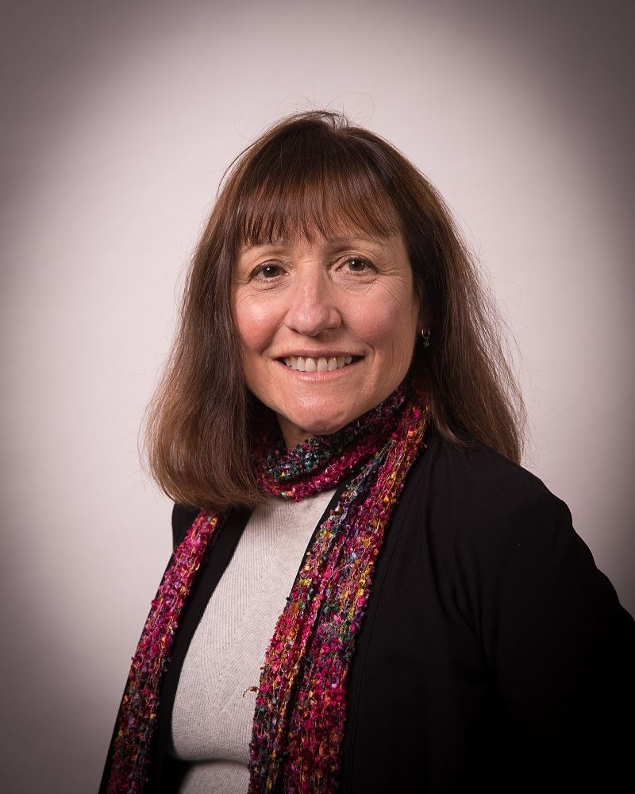  Jennifer Taub |   Ana Devlin-Gauthier    Robert (Bob) Hegner

Amherst School Committee Members
Name | Title | Email address | Term End
Jennifer Shiao | Chair | Shiaoj@arps.org | Dec 31, 2025
Bridget Hynes | Vice Chair | Hynesb@arps.org | Dec 31, 2025
Deborah Leonard | Secretary | LeonardDSC@arps.org | Dec 31, 2025
Sarah Marshall | Member | Marshalls@arps.org | Dec 31, 2025
Irv Rhodes | Member | Rhodesi@arps.org | Dec 31, 2025

Email address (not pubic comment): AmherstSchoolCommittee@arps.org
Public comment email address: SCpubliccomment@arps.org - please note, this email address will go to the entire school committee as well as the Superintendent, and be published as public information attached to final meeting minutes.

Amherst-Pelham Regional School Committee Members

Name | Title | Town | Email address | Term ends
Sarahbess Kenney | Chair | Pelham | Kenneys@arps.org | Dec 31, 2025
William Sherr | Vice Chair | Pelham | Sherrw@arps.org | Dec 31, 2025
Bridget Hynes | Secretary | Amherst | Hynesb@arps.org | Dec 31, 2025
Anna Heard | Member | Shutesbury | Heardh@arps.org | Dec 31, 2025
Deborah Leonard | Member | Amherst | LeonardDSC@arps.org | Dec 31, 2025
Sarah Marshall | Member | Amherst | Marshalls@arps.org | Dec 31, 2025
Irv Rhodes | Member | Amherst | Rhodesi@arps.org | Dec 31, 2025
Tillman Wolf | Member | Leverett | Wolft@arps.org | Dec 31, 2025

Email address (not public comment): RegionalSchoolCommittee@arps.org
Public Comment Email address: SCpubliccomment@arps.org - please note, this email address will go to the entire school committee as well as the Superintendent, and be saved as public information attached to final meeting minutes.

